MACHINE LEARNING PROJECT (PINNACLE)
ON
PREDICTING SOLAR FLARE

IN PARTIAL FULFILLMENT OF THE REQUIREMENT FOR THE
DEGREE OF BACHELOR OF TECHNOLOGY
OF
uGDX SCHOOL OF TECHNOLOGY AT ATLAS SKILLTECH UNIVERSITY

Submitted By

Megh Bari – 2410232
Kuunal Mistry – 2410130
Manvith Rai – 2410286
Aayushi Purohit – 2409900
Ruchita Wagh – 2410891

UNDER THE GUIDANCE OF
RUSHIKESH MEHARWADE SIR
SOHEL DAS SIR


1. Problem Statement
Overview
Solar flares are explosive bursts of electromagnetic radiation from the Sun. Their impact is far-reaching: disrupting satellite operations, GPS navigation systems, aviation communication, and even large-scale power grids. As societies and economies become increasingly dependent on these technologies, the risk posed by solar flares has grown significantly.
Detailed Description of the Problem
Traditional flare prediction relies on manual expert analysis of solar images and measurements. This approach is:
- Slow: Human interpretation cannot keep pace with the enormous data streams from modern satellites.
- Subjective: Results may vary between experts, reducing consistency.
- Reactive, not proactive: By the time a flare is detected, its impact may already be imminent.
The consequence of inaccuracy is high. For example:
- Airlines may be forced to reroute flights, incurring millions in costs.
- Satellite systems worth billions could sustain damage.
- Power grid failures could disrupt entire regions, causing both economic and human safety risks.
Thus, the project’s core goal is to design a machine learning–based system that automates flare prediction. Such a system can provide early warnings, reduce manual dependency, and ensure faster, more accurate forecasting.

2. Data Details
Data Sources
- NASA Space Weather Data (2023–2024) curated by Eda Çelikeloğlu.
- NOAA solar observation archives, containing decades of historical flare records.
- Other NASA missions capturing magnetograms, coronal mass ejection records, and X-ray flux data.
Validity of Data
The datasets are direct observations of solar activity, making them highly suitable for flare prediction. Their reliability is strengthened by:
- Being sourced from trusted agencies (NASA, NOAA).
- Covering multiple solar cycles, ensuring diversity of flare patterns.
- Containing both flare-related and non-flare periods, which allows the model to learn distinguishing features.
In short, the data is both scientifically credible and practically relevant.
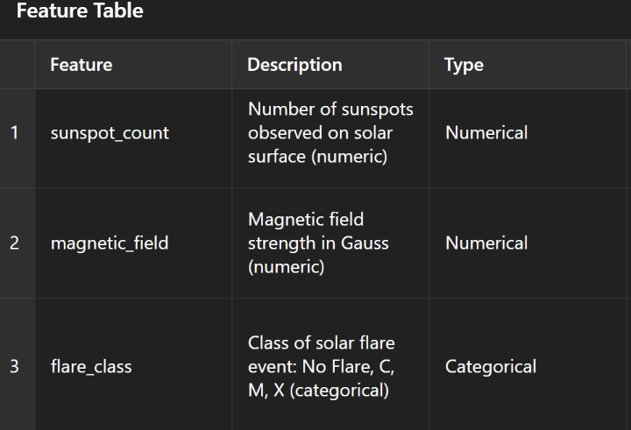

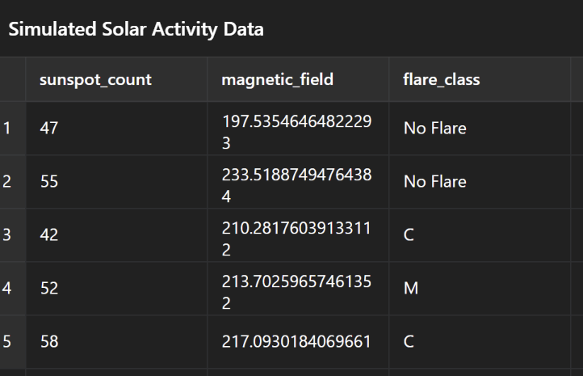

3. Type of ML Problem
This is a classification problem:
- Binary Classification: Predicting if a flare will occur (Yes/No) within a future time window.
- Multi-Class Classification: Predicting flare intensity levels based on standard categories:
  - C-Class (low intensity)
  - M-Class (medium intensity, potentially disruptive)
  - X-Class (high intensity, severely disruptive).
This allows flexibility: the binary model is useful for quick warnings, while the multi-class model helps gauge the scale of potential disruption.

4. Exploratory Data Analysis (EDA)
Features Studied
- Sunspot Counts: Large sunspots are correlated with flare events.
- Magnetic Field Strength: Stronger, unstable fields increase flare probability.
- Flare Class Labels: Historical classification of solar flares (No Flare, C, M, X).
Insights from Sample EDA
- Histogram of Sunspot Counts

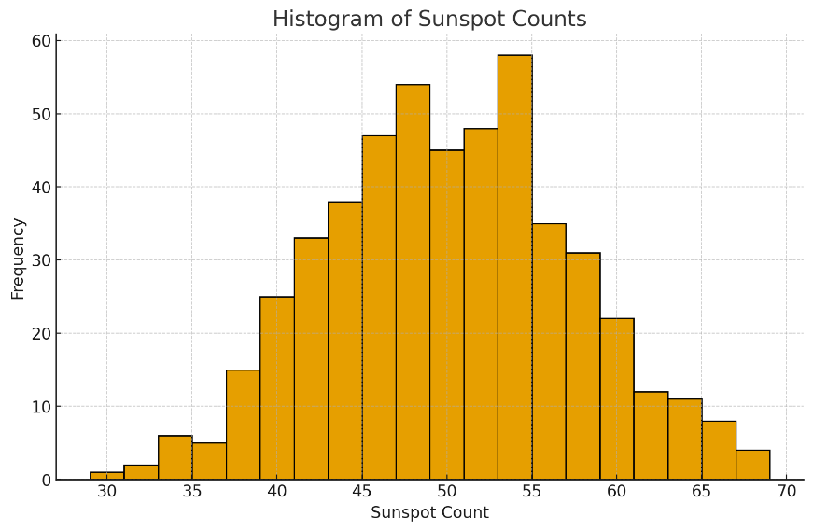

  - Distribution is centered around 40–60 counts in the simulated data.
  - Suggests that most days have moderate activity, with fewer extreme outliers.
  - In real datasets, high sunspot counts often correlate with active solar periods.

- Histogram of Magnetic Field Strength
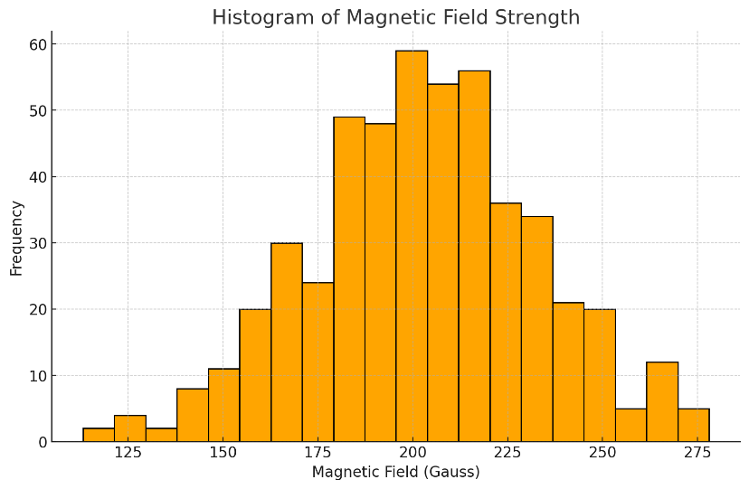
  - Normally distributed around 200 Gauss.
  - Extreme deviations (very high or very low fields) may indicate instability, which is a precursor to flares.

- Bar Chart of Flare Class Distribution
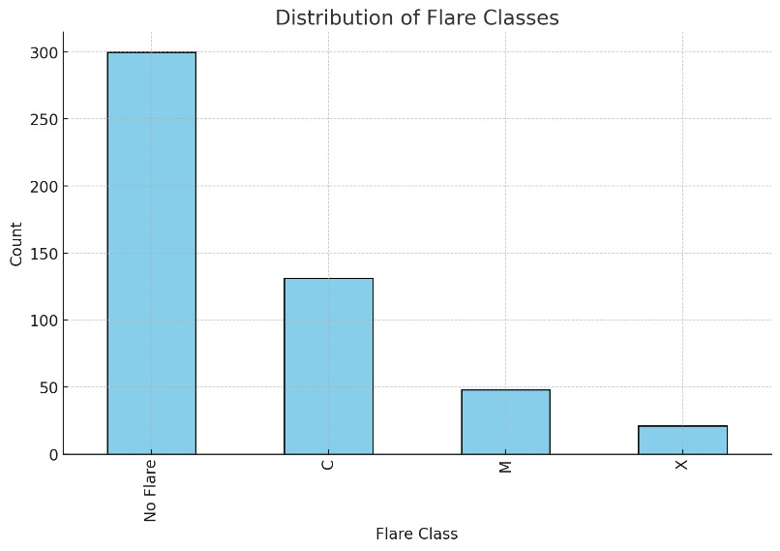
  - Majority class: “No Flare” (class imbalance issue).
  - Minority classes: M and X flares are rare but critical to predict.
  - This imbalance highlights the need for balanced sampling techniques or weighted loss functions.
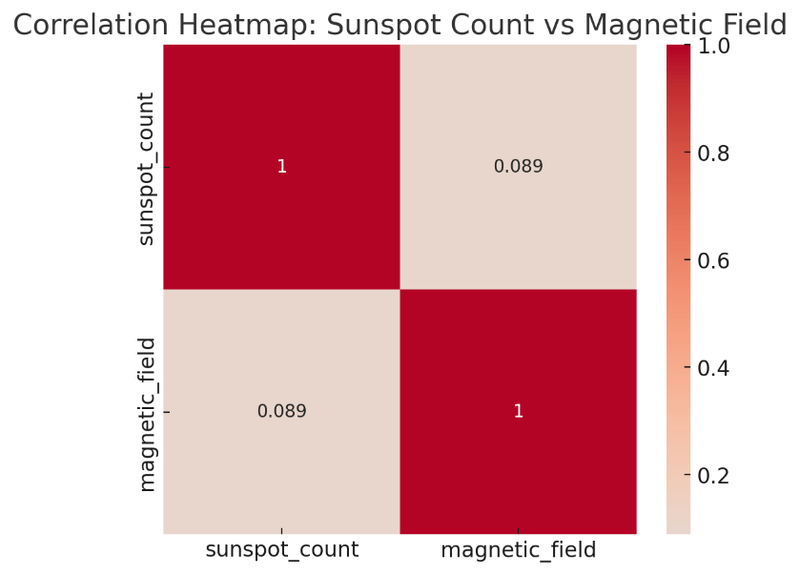
Through EDA, we confirm that the dataset captures the statistical imbalance and physical signals relevant to solar flare prediction.

5. ML Pipeline Structure
Steps in the Pipeline
- Data Preprocessing
  - Handling missing or inconsistent values.
  - Synchronizing timestamps from multiple sensors.
- Feature Engineering
  - Rate of change in sunspot counts.
  - Variability in magnetic field strength.
  - Time-lagged features to capture short-term flare precursors.
- Train-Test Split
  - Time-aware splitting: Data is split chronologically to avoid “future leakage.”
  - Ensures the model is tested on unseen, later solar activity.
- Modeling Approaches
  - Random Forests for interpretability and feature importance.
  - Gradient Boosting (XGBoost/LightGBM) for handling class imbalance.
  - Neural Networks (LSTMs) for time-series sequence modeling.

6. Evaluation Methods
Statistical Metrics
- Precision: Prevents unnecessary false alarms (important for aviation/defense).
- Recall: Ensures that high-risk flares are not missed.
- F1 Score: Balances both precision and recall.
- ROC-AUC: Measures robustness across different thresholds.
Business & Practical Impact
- Satellite Protection: Timely warnings prevent billions in damages.
- Aviation Safety: Aircraft communication remains reliable.
- Power Grid Stability: Reduces risk of widespread outages.
- Revenue Protection: Mitigates losses from rerouting, downtime, or equipment damage.
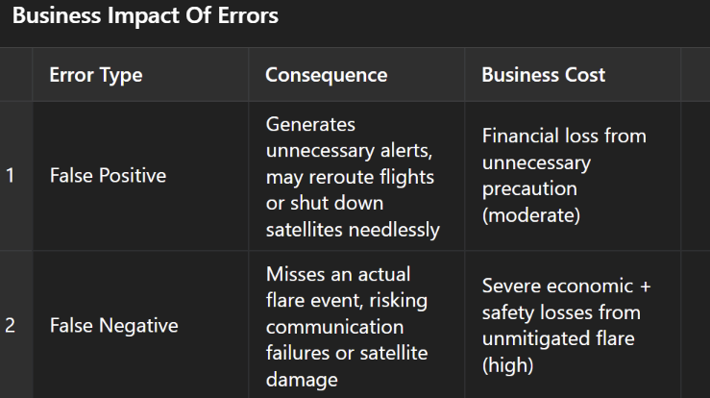
By combining statistical rigor with real-world business impact, the evaluation framework ensures that the model is both scientifically valid and operationally useful.

7. Next Steps
- Expand dataset to include multiple solar cycles.
- Perform full EDA on actual NASA/NOAA data, replacing placeholders.
- Build baseline ML models and tune hyperparameters.
- Deploy best-performing model in a real-time prediction system.
- Document results in a final technical + business report for stakeholders.

